**V-Q & P-Angle Relationships**



**Javier Jesús Macossay-Hernández**

**EE443 – Introduction to Power Systems**

**University of Southern California**

**Professor Robert Castro**

**Objective**

In power engineering, a power flow study usually uses simplified notations to focus on various aspects of AC power parameters, such as voltages, voltage angles, real power, and reactive power. Power flow analyzes the power systems in normal steady-state operation. In addition, we are able to modify the direction of real power and reactive power if we change the voltage angle and the voltage, respectively. Design Case 2 from PowerWorld will be used on this problem do demonstrate the relationship between voltage and reactive power and real power and voltage angle.

**Introduction**

In Figure 1, we can see Design Case 2. This is the case I will use to perform my problem.

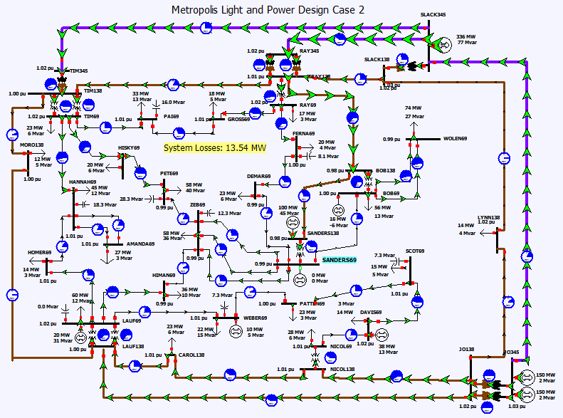

Figure 1: Design Case 2

The steps to complete this problem are the following:

1. Choose a value with two buses on the beginning and end, then transmission lines are needed to connect them.
2. Gather information from PowerWorld (sending, receiving end voltages and angles, transmission line impedance).
3. Prove the V-Q and P-Ange relationship using active power equation for real power and the equivalent equation for reactive power.
4. Conclude.

**Methods**

As mentioned before, the first thing to do is to choose an area with two buses and transmission line. The following area is:

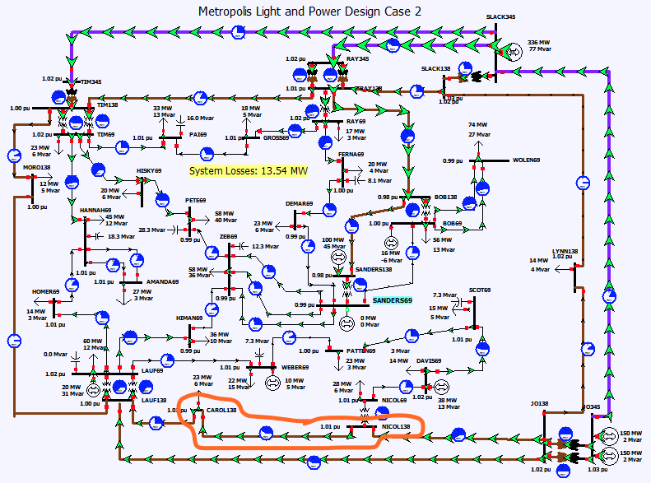

Figure 2: Chosen area on Design Case 2

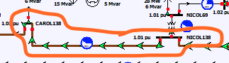

Figure 2: Chosen transmission line

Figure 2: Shows that the chosen area consists of 2 buses, CAROL138 and NICOL138, and a transmission line.

In this problem, the bus NICOL138 will be point A (sending end point) and the bus CAROL138 will be defined as point B (receiving end point). This will be shown in Figure 4 where Vs is NICOL138’s sending end voltage, Vs (angle) is NICOL138’s sending end angle, Vr is CAROL138’s receiving end voltage, Vr (angle) is CAROL138’s receiving end angle, and X is the transmission line impedance.

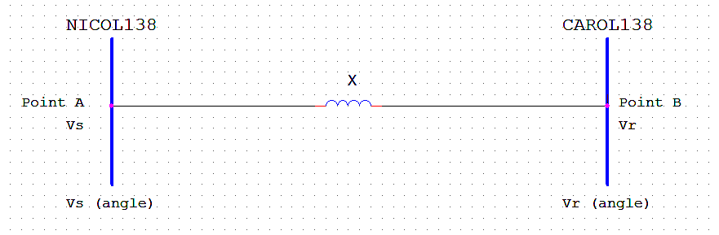

Figure 4: The two buses and transmission line are shown.

**Calculations**

By using PowerWorld, the values shown in the following figures 5 were obtained:

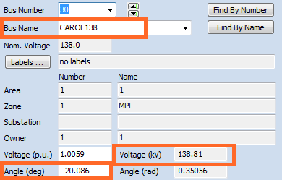

Double click on CAROL138

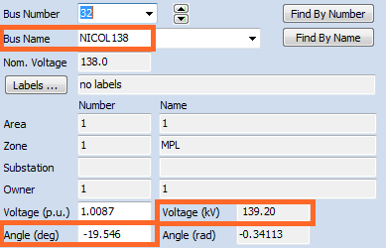

Double click on NICOL138

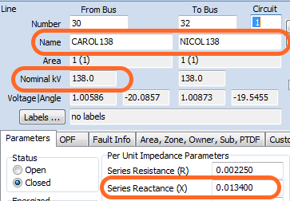

Double click on transmission line

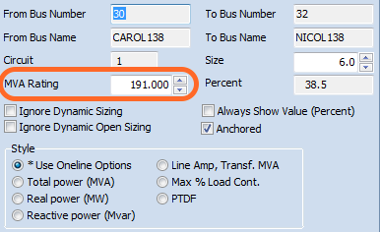

Double click on pie chart

The previous figures show the following values:

Vs = 139.2 kV

Vr = 138.81 kV

Vs (angle) = -19.546°

Vr (angle) = -20.086°

Xpu = j0.0134 pu

Vnominal = 138 kV

Snominal = 191 MVA

Now, I will show the relationship between then real power and the voltage. The power flow can be calculated as follows:

Z = $\frac{V^{2}nominal}{S nominal}$ = $\frac{{\left(138 kV\right)}^{2}}{191 MVA}$ = 99.7 Ω

Xactual = Z*Xpu = (99.7 Ω) (j0.0134 pu) = j1.34Ω

P = $\frac{\left|Vs\right|*\left|Vr\right|}{Xactual}*\sin\left|Vs\left(angle\right)-Vr\left(angle\right)\right|$ = $\frac{\left|138.81 kV\right|*\left|139.2 kV\right|}{j1.34 ohms}*\sin\left|-20.086 degrees-(-19.546 degrees)\right|$ = 135.9 MW

Therefore, the power is 135.9 MW. I will increase by 50% the value of the sending end voltage. Then, I will increase by 50% the sending end voltage angle. I will proceed to perform these calculations to confirm that the real power has a stronger correlation with the angle and, as a result, the changes in the angle affect more the real power.

Vs = 139.2 kV

Vs + 50% Vs = 139.2 kV * 1.5 = 208.8 kV

Vs (angle) = -19.546°

Vs (angle) + 50% Vs (angle) = -19.546° * 1.5 = -29.319°

Real Power with a 50% increase of the sending end voltage

P = $\frac{\left|138.81 kV\right|*\left|208.8 kV\right|}{j1.34 ohms}*\sin\left|-20.086 degrees-(-19.546 degrees)\right|$ = 203.9 MW

Real Power with a 50% increase of the sending end voltage angle

P = $\frac{\left|138.81 kV\right|*\left|139.2 kV\right|}{j1.34 ohms}*\sin\left|-20.086 degrees-(-29.319 degrees)\right|$ = 2313.6 MW

From the results we can conclude that the angle has a stronger impact in the value of the real power than the voltage. Another way of proving this relationship is if I increase by 50% the angle between the sending end voltage angle and the receiving end voltage angle.

V (angle) + 50% V (angle) = (20.086° - 19.546°) * 1.5 = 0.81°

Real Power with a 50% increase of the angle between the sending end voltage angle and the receiving end voltage angle

P = $\frac{\left|138.81 kV\right|*\left|139.2 kV\right|}{j1.34 ohms}*\sin\left|0.81 degrees\right|$ = 203.85 MW

The increase of the real power is directly proportional to the one in the voltage angle. Now, I will use the reactive power equation to show the V-Q relationship.

Q = $\frac{\left|V\right|*|Ef|}{Xactual}\cos\left(angle\right)-\frac{V^{2}}{Xactual}$ where V = generator terminal voltage, Ef = generator magnetic field volt

I will use the sending end values for voltage angle and voltage. I will increase by 10% the value of Ef. Then, I will increase by 10% the sending end voltage angle. I will proceed to perform these calculations to confirm that the reactive power has a stronger correlation with the voltage and, as a result, the changes in the voltage affect more the reactive power.

Assume Ef = 150 kV

Ef + 10% Ef = 150 kV * 1.1 = 165 kV

Vs = 139.2 kV

Vs (angle) = 19.546°

Vs (angle) + 10% Vs (angle) = 19.546° * 1.1 = 21.5006°

Reactive Power without modification to its original values

Q = $\frac{\left|139.2 kV\right|*|150 kV|}{j1.34 ohms}\cos\left(19.546 degrees\right)-\frac{{139.2}^{2}}{j1.34 ohms}$ = 223.964 MVAR

Reactive Power with a 10% increase of Ef

Q = $\frac{\left|139.2 kV\right|*|165 kV|}{j1.34 ohms}\cos\left(19.546 degrees\right)-\frac{{139.2}^{2}}{j1.34 ohms}$ = 1692.38 MVAR

Reactive Power with a 10% increase of Vs (angle)

Q = $\frac{\left|139.2 kV\right|*|150 kV|}{j1.34 ohms}\cos\left(21.5006 degrees\right)-\frac{{139.2}^{2}}{j1.34 ohms}$ = 37.611 MVAR

As seen in the previous equations, the reactive power increased as Ef increased. In addition, it decreased when Vs (angle) increased. Therefore, the reactive power is directly proportional to Ef and inversely proportional to Vs (angle).

**Results**

*Real Power – 135.9 MW*

|  |  |
| --- | --- |
| Vs increase | Vs (angle) increase |
| 203.9 MW | 2,313.6 MW |

*Reactive Power – 223.964 MVAR*

|  |  |
| --- | --- |
| Ef increase | Vs (angle) increase |
| 1,692.38 MVAR | 37.611 MVAR |

In conclusion, the angle has a stronger impact in the value of the real power than the voltage. In addition, the voltage has a stronger impact in the value of the reactive power than the angle. Therefore, the V-Q and P-Angle relationships are true.

**Discussion**

In this problem the concept of using the real and reactive power equations were introduced. Information from PowerWorld was gathered (sending, receiving end voltages and angles, transmission line impedance). In addition, manual calculations were performed to prove the V-Q and P-Angle relationships. As mentioned in the results section, the relationships were proven in this problem